PRESS RELEASE
COMMUNICATIONS AND MEDIA TEAM OF THE 43RD ASEAN SUMMIT 2023
No. 71/SP/TKM-ASEAN2023/ENG/9/2023

ASEAN Community, Resilient Community
Jakarta, 4 September 2023 – The COVID-19 pandemic swept across the world in 2020. At that time, Wahid, a 45-year-old odd job worker and a native of Serpong in South Tangerang City, suddenly lost his source of income. He lamented, “I usually work as an ojek (motorcycle taxi) driver, picking up and dropping off students. Suddenly, schools shifted to long-distance learning. Everyone stayed home. No one needed my service.”
Around 3,500 kilometers away from Wahid’s home, there is Aroon Tanawat, a 42-year-old Chiang Mai resident skilled in cooking. He used to run cooking classes for tourists and promoted his classes through social media. At least two tourists would sign up every day. Unfortunately, the pandemic brought the tourism industry to a halt, which subsequently affected Aroon’s activities.
That was when ASEAN sprang into action. The association activated regional mechanisms, consisting of standards for information exchange and cooperation. The ASEAN BioDiaspora Virtual Center was established immediately, providing a basis for the governments of member states to make decisions to address the outbreak. Over time, the organization initiated the establishment of a more advanced pandemic response while simultaneously building resilience in case of future health threats. All can be achieved through dialogue, development, and cooperation among ASEAN member states.
Beyond the frenzy within the ranks of government and the grief due to the seemingly never-ending casualties, the pandemic had a positive impact on the digital economy in Southeast Asia. There are around 40 million new internet users in Indonesia, Malaysia, the Philippines, Vietnam, and Thailand. Restrictions on activities during the COVID-19 outbreak forced people to shop from home, leading to a direct surge in e-commerce businesses by 63%.
The economy continued to develop, accelerating even further after the ASEAN countries successfully navigated through the pandemic period.
Indonesia even regained its status as an upper-middle-income country this year according to the World Bank. The basis for this assessment is Indonesia's annual Gross National Income (GNI) per capita, which reached $4,580 in 2022. During the pandemic, Indonesia's status was “downgraded”. Regaining the status of an upper-middle-income country makes it clear that Indonesia has recovered from the pandemic.
Indonesia was not the only one demonstrating its resilience. Other ASEAN countries have shown similar trends. For example, Singapore recorded 0.7% (year on year) growth in Q2 of 2023, up from 0.4% in the previous quarter. The Philippines also displayed a positive economic momentum. The Philippines Statistics Authority (PSA) released data indicating that all their major economic sectors grew positively in Q2 of 2023. The country’s economy grew by 4.3% annually in this quarter. Contributors to the Philippines’ economic growth in this quarter, among others were wholesale and retail trades, as well as motor vehicles, which amounted to 5.3%.
Meanwhile, Vietnam posted an economic growth rate of 4.14% in Q2 of 2023. Although Vietnam’s government acknowledged that its economy has slowed down, the growth rate remained robust in the face of global challenges.
The Southeast Asian region continues to grow. Leading up to the 43rd ASEAN Summit, one of the ministerial meetings was the ASEAN Economic Community Council (AECC) on Sunday (3 September 2023). The meeting discussed the economic pillar of ASEAN. It was revealed during the meeting that the total GDP (Gross Domestic Product) of ASEAN amounted to US$3.6 trillion in 2022. ASEAN’s economic growth in 2024 is projected to be the highest in the world, reaching 4.5%.
ASEAN is also the most attractive region for Foreign Direct Investment (FDI). In 2022, 17% of FDI entered ASEAN, making it the highest recipient of FDI compared to other developing countries. This is impressive data and is testament to investor’s confidence in the long-term prospects of Southeast Asia.
ASEAN’s resilience was tested again during the conflict between Russia and Ukraine. The global conflict briefly caused an increase in commodity prices, considering that the two warring countries are major exporters of fossil fuels, grains, fertilizers, and metals. However, the conditions improved immediately. Although not fully restored to its previous state, the impact of the Ukraine–Russia conflict could be mitigated by the ASEAN Community.
The ASEAN community is resilient. The resilience did not appear on its own. It was cultivated through the policies and efforts of its government.
The current state of ASEAN is a manifestation of the ASEAN Community Vision launched in 2015. In the vision, it is stated that the goal of the community is to establish a community of nations that “enjoys human rights and fundamental freedoms as well as thrive in a just, democratic, harmonious, and gender-sensitive environment in accordance with the principles of democracy, good governance, and the rule of law”.
The ASEAN Community Vision has faced challenges when several member states experienced political upheaval. The ASEAN community has not remained a passive observer when Myanmar is facing a conflict. Similar reactions occurred during political turmoil in Thailand. However, all parties exercised restraint from intervening in the internal politics of neighboring countries because this principle is one of ASEAN’s objectives, namely the principle of non-interference.
ASEAN Matters: Epicentrum of Growth
The theme of Indonesia’s ASEAN Chairmanship in 2023 is “ASEAN Matters: Epicentrum of Growth”. There are three pillars of the theme. The first pillar is “ASEAN Matters”, to ensure that ASEAN remains relevant, capable of facing future challenges, and continues to serve as a driver of regional stability and peace. This pillar emphasizes the importance of ASEAN’s role in promoting growth and stability in the region.
The second pillar is the “Epicentrum of Growth”, which encourages concrete cooperation to ensure that its benefits can be felt by the people. It is hoped that the Southeast Asian region can become a center of global economic growth. The last pillar is related to the Implementation of AOIP (ASEAN Outlook on the Indo-Pacific). The AOIP is a commitment to build concrete and inclusive cooperation with all nations to make the Indo-Pacific a peaceful and prosperous region.
The ASEAN Summit must certainly result in policies, not merely meetings and discussion forums. The summit is a platform for the ASEAN community to formulate strategies and establish cooperation to address global challenges in the future. It is the duty of ASEAN leaders to continue inspiring hope to the people. If lowering labor costs proves to be challenging, a reasonable solution is to encourage innovation, research, and development to build a more advanced economy.
Wahid is active again now. In addition to providing ojek services, he now works on electrical installations and manages yards. Through an empowerment program held in his urban village, his wife has learned to manage a small-scale catering business. At the very least, their small family has an additional source of income. "Before I deliver my wife's merchandise, I call the women in the neighborhood one by one. I ask them for jobs. Usually, there is one. For example, I’d be asked to go shopping at the market or pick up the children from school, riding my motorcycle. Well, I am up for it. It is not bad to get Rp25,000," he said with a laugh.
Whereas Aroon, as Thai tourism recovers, is also busy with his cooking classes. Now, classes run a maximum of two times, each class serving four tourists. With a low-interest government loan, he renovated his terrace into a cooking class location. Currently, there are four stoves and four preparation tables, as well as a dining room where the participants of the cooking class enjoy their culinary creations.
They, like other Southeast Asians, have now returned to their pre-pandemic lives. However, they also place their hopes on ASEAN leaders. They certainly want a better life. The policies that will come out of the 43rd ASEAN Summit must be implemented promptly to address the needs of people like them.
Although the future is uncertain, there are things that we can continue to strive for together: stability, peace, and prosperity in the region. (Diana/Elvira/TR/Wisnu)
***
For more information, please contact:
Director General of Public Information and Communications of the Ministry of Communications and Informatics – Usman Kansong (0816785320).
Get more information at http://asean2023.id, https://infopublik.id/kategori/asean-2023, and https://indonesia.go.id/kategori/ragam-asean-2023

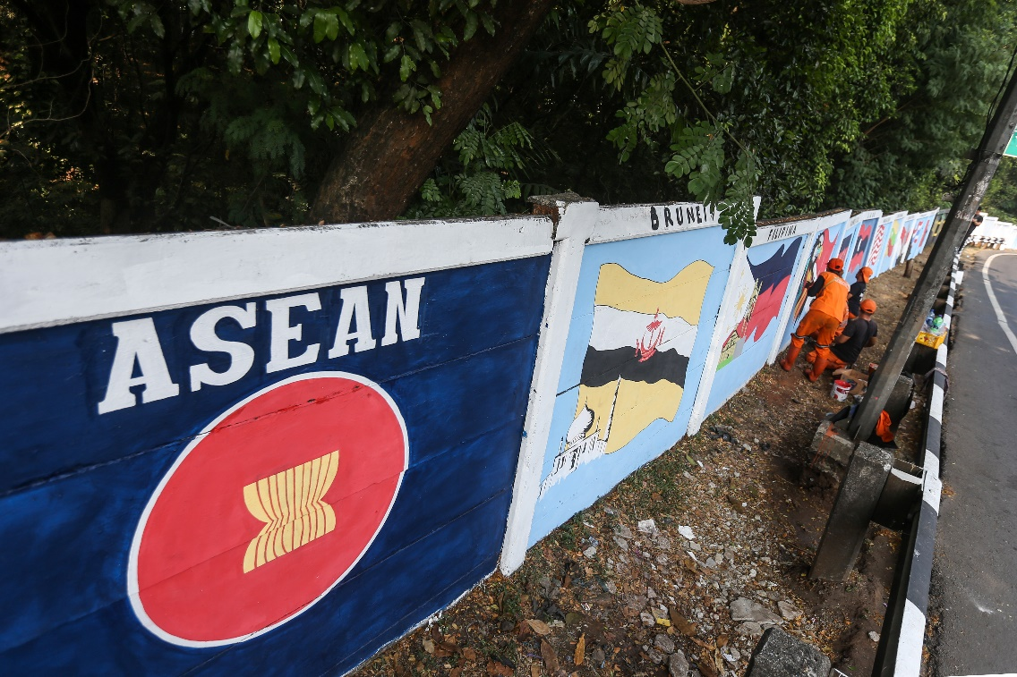
Public Facility Maintenance Agency (PPSU) staff put on finishing touches to a mural welcoming the ASEAN Summit on Jalan Raya Haji Bokir bin Djiun, East Jakarta, on Friday (25 August 2023). The mural is created to beautify the road in the area which serves as a route for the delegates of the ASEAN Summit 2023 in Jakarta. ANTARA FOTO/Asprilla Dwi Adha/nz.

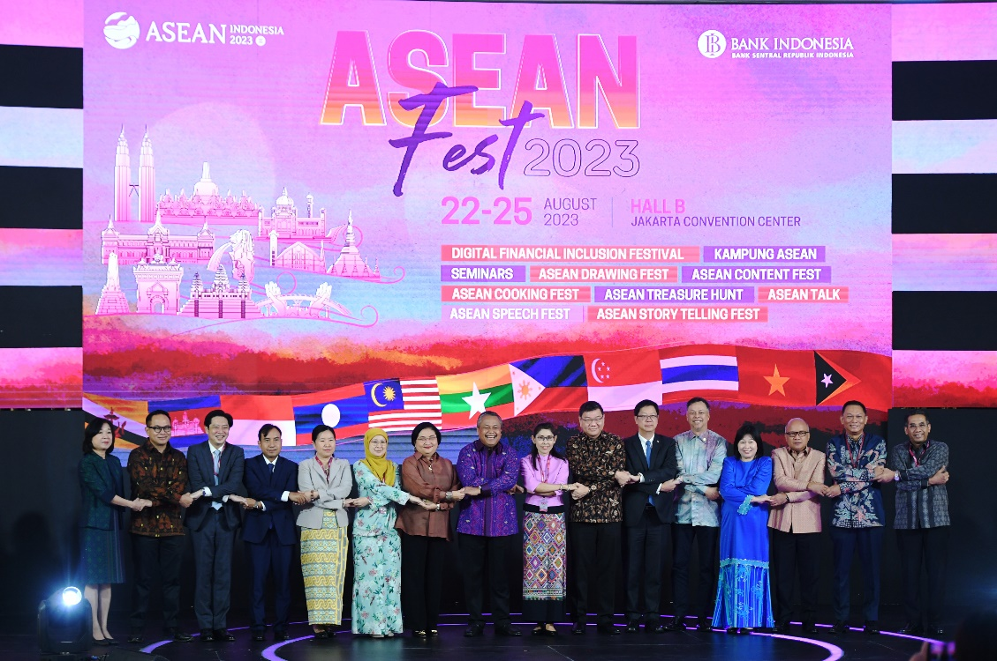

Governor of Bank Indonesia (BI) Perry Warjiyo (eight left) with Governor of Central Bank of Thailand Sethaput Suthiwartnarueput (sixth right) and Ambassadors as well as representatives from ASEAN countries pose for a picture during the opening of the ASEAN Fest 2023 at the Jakarta Convention Center, Jakarta, Tuesday (22 August 2023). The ASEAN Fest 2023, held from 22 – 25 August 2023, is filled with financial seminars, MSME exhibitions and the ASEAN Village. It serves as a supporting event for the 2nd ASEAN Finance Ministers’ and Central Bank Governors’ (AFMGM) Meeting. ANTARA FOTO/Hafidz Mubarak A/tom.

